John Michael Go
Career Entry Level Java Programming
Date: Jan. 17, 2013

DAY 5

Program Name: DateTime5

Objective: Fifth Date and Time example

Algorithm:

- Program outputs fifth date and time format.

Flowchart:

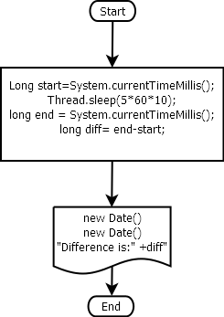

Pseudocode:

/* Program Name: DateTime5
Created By: John Michael Go
Creation Date: Jan. 17, 2013 Day 5
Note: Fifth Date and Time example
*/

import java.util.*;

public class DateTime5{

public static void main(String[]args){

try{
Long start=System.currentTimeMillis();
System.out.println(new Date()+"\n");
Thread.sleep(5*60*10);
System.out.println(new Date()+"\n");
long end = System.currentTimeMillis();
long diff= end-start;
System.out.println("Difference is:" +diff);

}catch (Exception e){
System.out.print("Got an Exception!");
}

}

}

Screenshots:

